How to create a simple XML Publisher Report
Posted on December 25, 2013
1. Navigate to System Administrator->Concurrent->Program->Define and create a new concurrent program as below with Executable as “XDODTEXE” and output as “XML“.
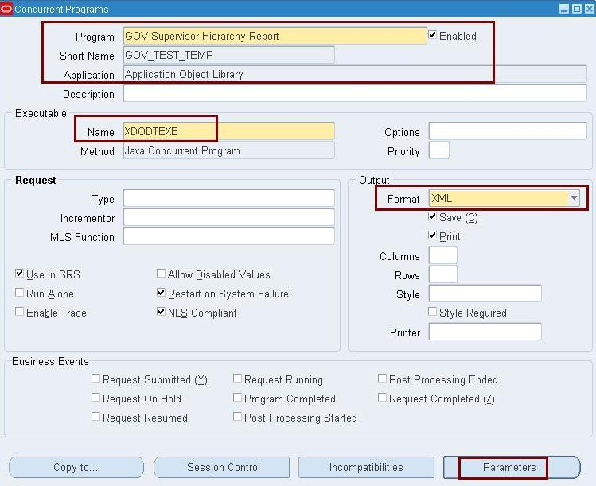
Then click on parameters button and enter the parameter as below
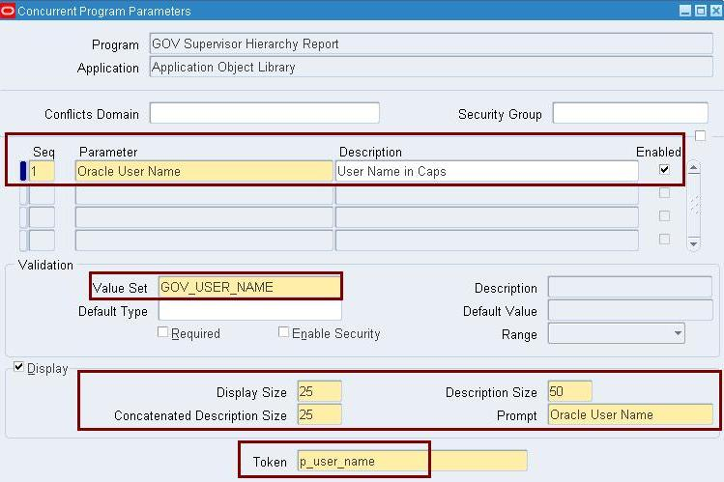
2. Navigate to System Administrator->Security->Responsibility->Request,query request group as “System Administrator Reports” & application as “Application Object Library“(Its the request group attached to System Administrator responsibility).Then add the newly created concurrent program to it.
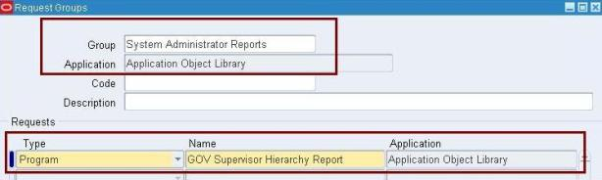
3. Below is the Data Definition template XML which is created and its explanation.
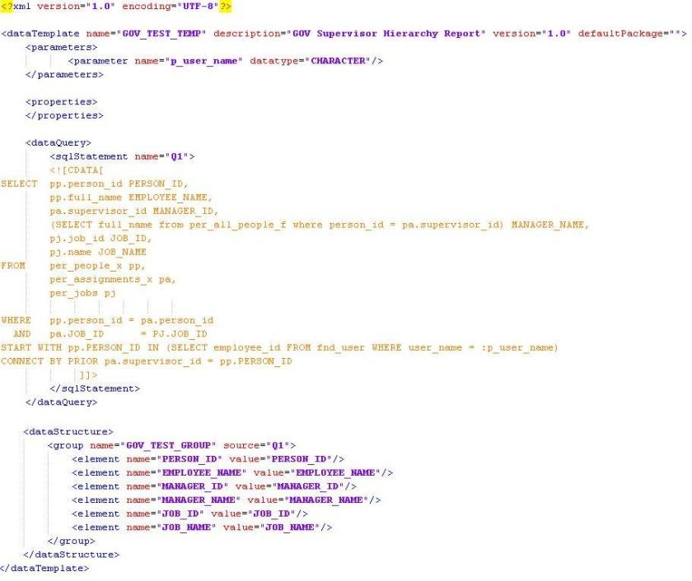
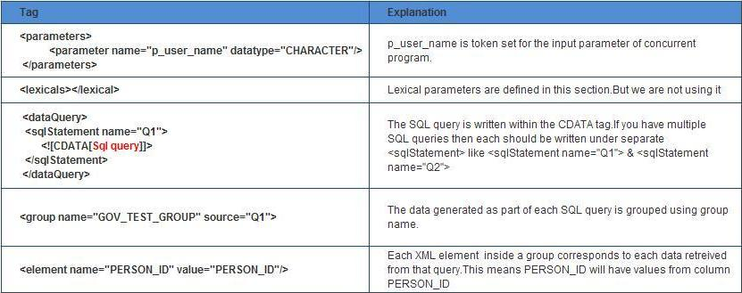
4. Navigate to XML Publisher Administrator->Home->Data Definitions, click on “Create Data Definition” button and create Data Definition as below.Data Definition Code should be same as the Concurrent Program Short name which we created.Then click on Apply button.
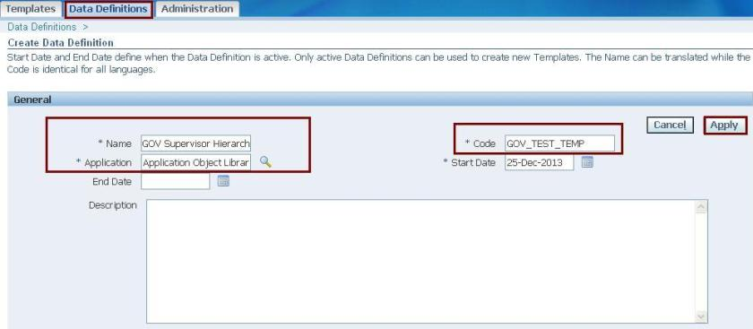
Attach the Data DefinitionTemplate XML which we created in step 3.
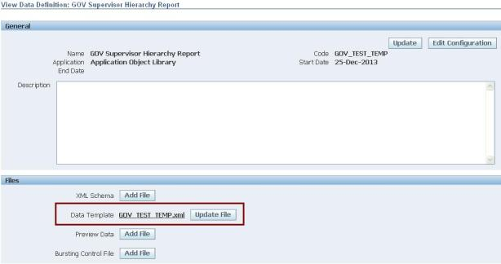
5. Navigate to System Administrator->Concurrent->Requests and submit the newly created concurrent program.
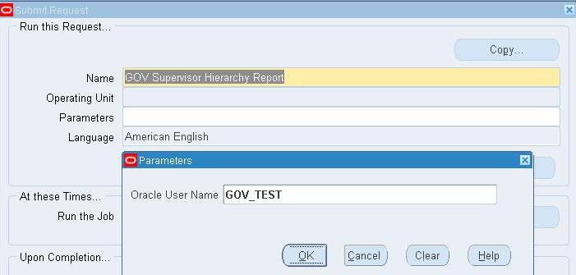
Once the program is completed,click on View output button and save the output in XML format.
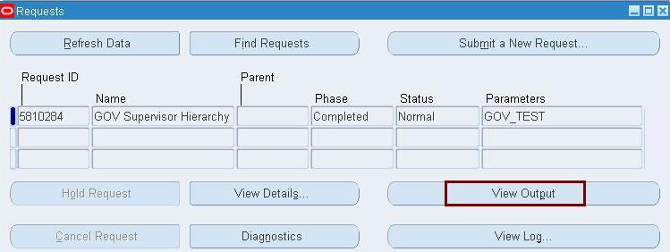
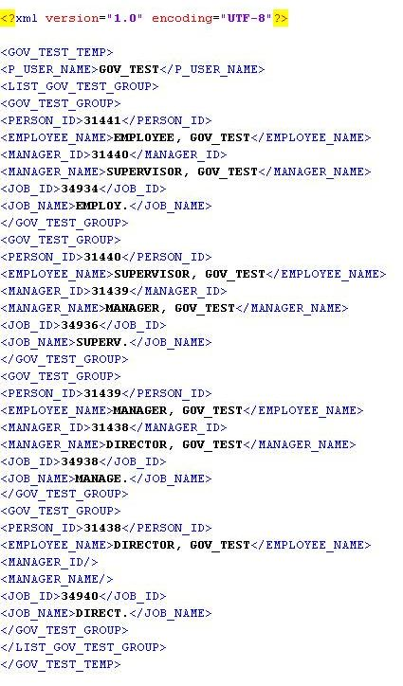
6. Open MS Word->Add-Ins->Data->Load XML Data and load the output XML file which we saved in previous steps.(Ensure BI Publisher Desktop is installed)
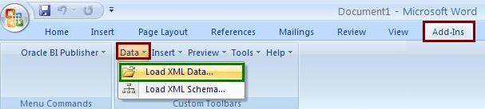
7. Then click on Oracle BI Publisher->Insert->Table Wizard
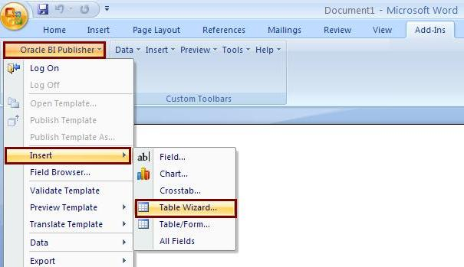
- Select report format as Table
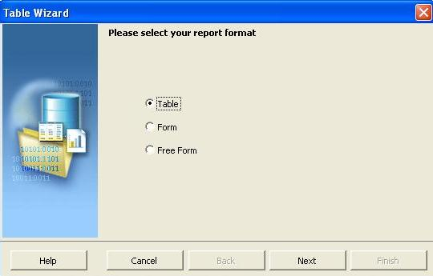
- Since we are having only one group that defaults.If multiple group are there in your data definition select the group.
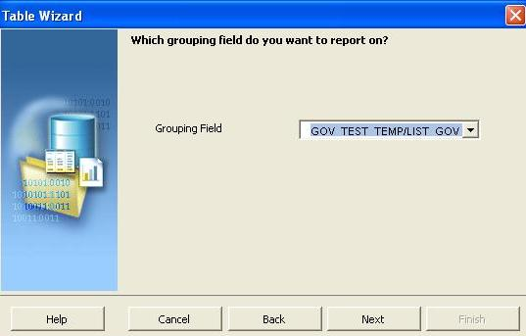
- Select all the fields and click finish button.(If sorting needs to be done,click next button instead of finish and do the settings).
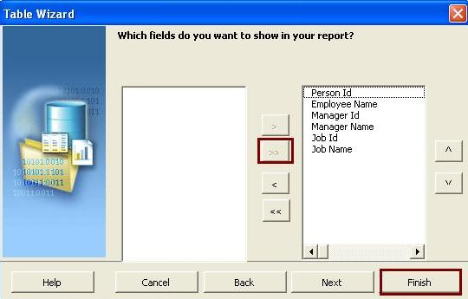
Below is the report format.Save the document as RTF file(Rich Text Format)
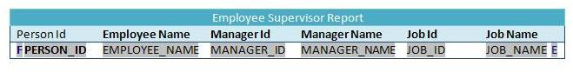
7. Navigate to XML Publisher Administrator->Home->Templates and click on Create Template button.
Assign the Data Definition template which we created in step 4 to this template and set Output type as PDF. Also Set the type as RTF and assign the RTF file created in previous step.Create the Template as below and Apply.
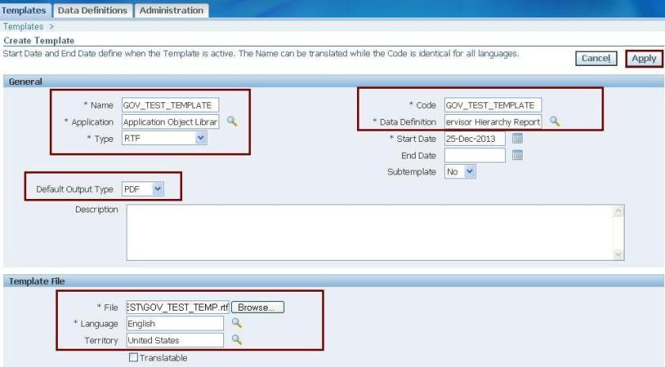
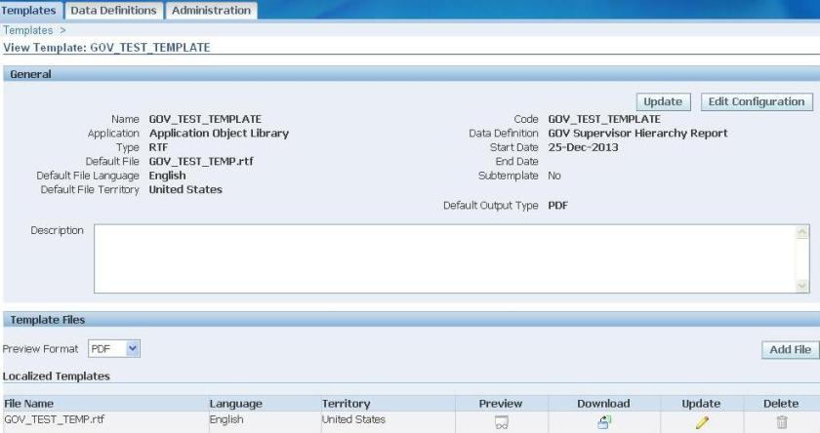
8. Navigate to System Administrator->Concurrent->Requests and once again submit the newly created concurrent program.Now if you click the output we can see the report which we created.
